REPORT

Data Cleaning:
After downloading the data from UCI, I cleaned it to fit into the linear regression model.
At first I have selected the numerical type columns from the dataset:-
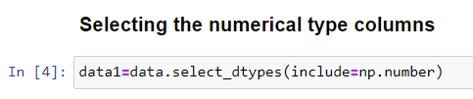

Then I count all NA values from the dataset.
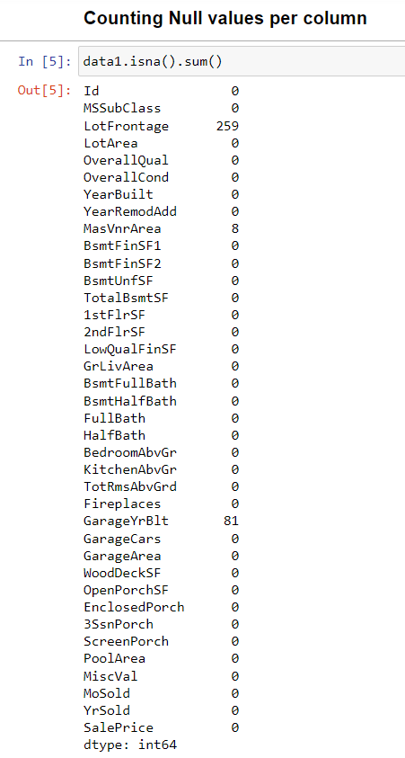

Since only few columns have NA values so I dropped them.
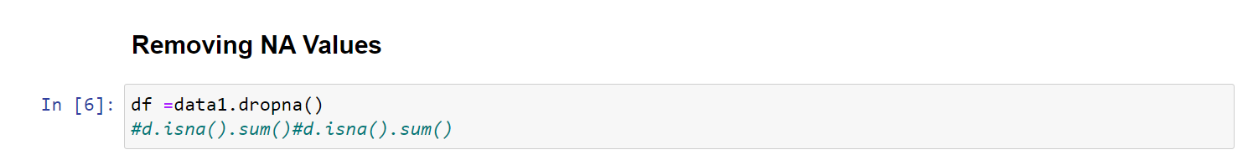

Then I have plotted the heat map of the correlation matrix

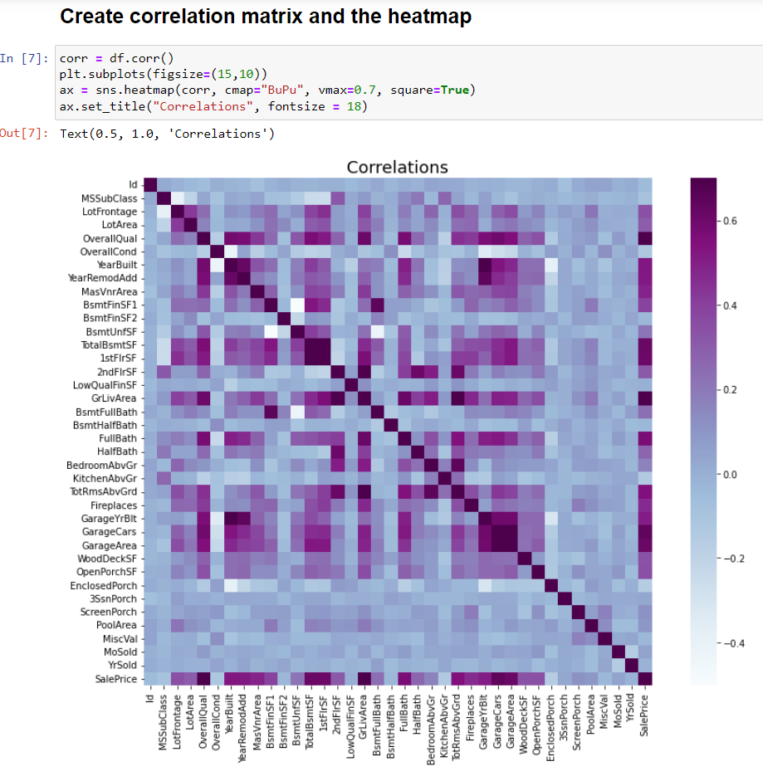

Using the correlation matrix heat map, I have selected the most suitable columns for linear regression.

Then I have converted the data frame into two numpy arrays, named them X and Y.

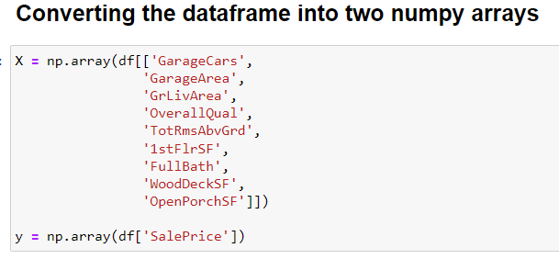

OLS Regression Results

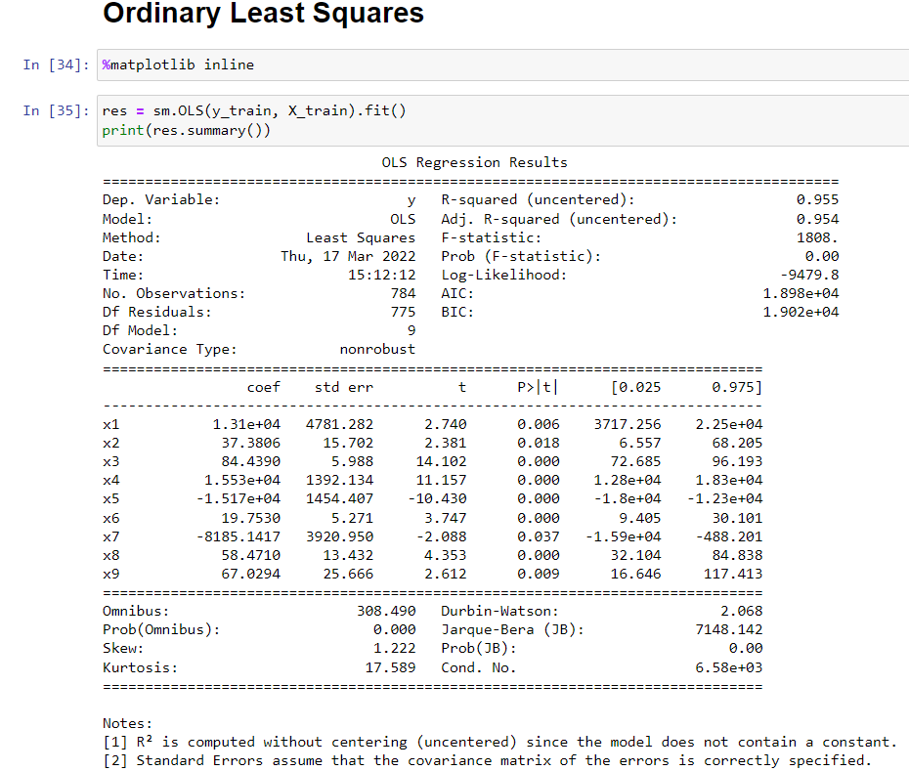

Batched Gradient Descent

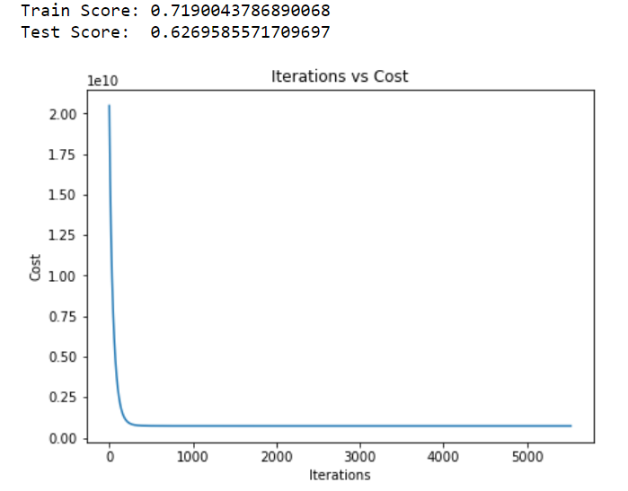

Sequential Gradient Descent

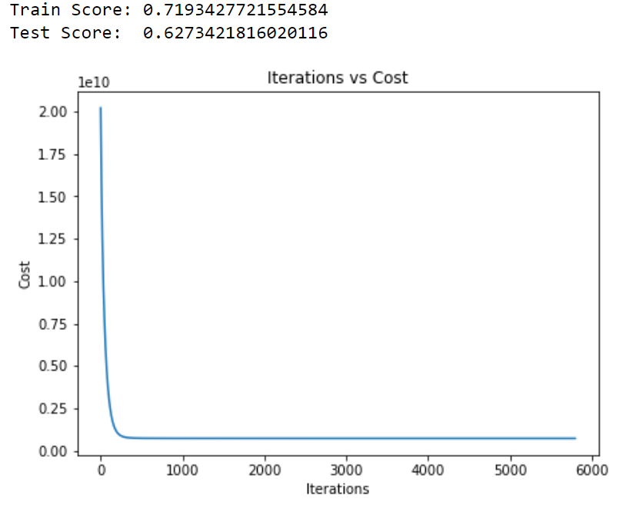

In this case Sequential Gradient Descent takes more iterations and give slightly better result than Batched Gradient Descent.

